

**Tukaram Krishnaji kolekar Arts and Commerce COLLEGE, Nesari**

At/post ,Nesari, Tal : Gadhinglaj.Dist: Kolhapur, Maharashtra, India.

**Shikshan samiti K|| Nesari’s**

G R N: NGC 3595/NMV/137/95 MS –3 Date: 4/8/1995

President

**Adv. H.T. Kolekar ( B.Sc. L.L.B)**

Principal

**Dr.S.B. Bhambar MA M.Phil Ph.D Ph.D**

**.**

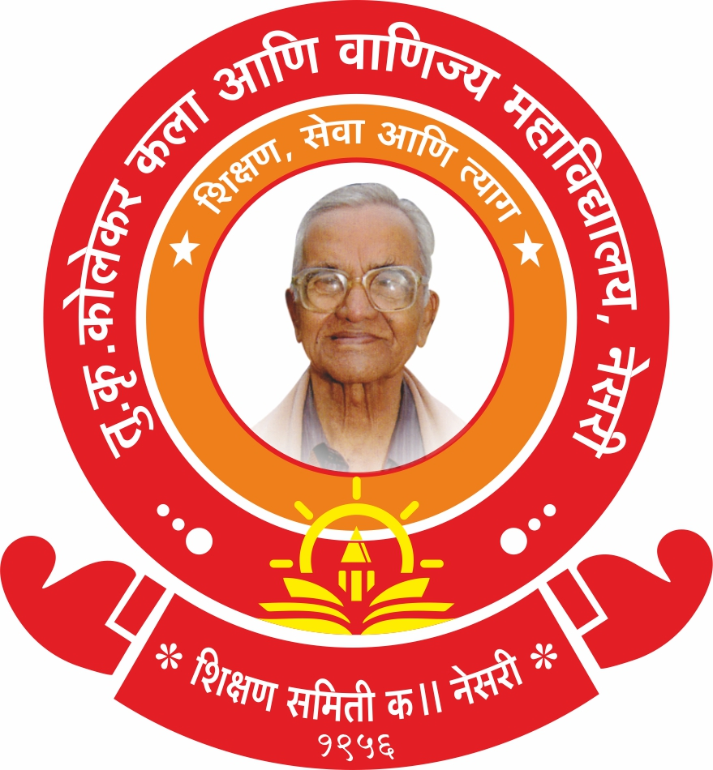

The Institution has Several Collaborations/Linkages for **Faculty Exchange**, **Student Exchange, Internship, Field Trip, On-The- Job Training, Research etc.**

**Academic Year: 2023-24**

|  |  |  |  |  |  |  |  |
| --- | --- | --- | --- | --- | --- | --- | --- |
| Sr. No. | Title of the Collaborative Activity | Name of the Collaborating Agency with Contact details | Name of the Participant | Date of Collaboration | Duration | Nature of the Activity | No. of Participants |
| 1 | Lecture on: Marathi Language and Earning Opportunities.  (मराठी भाषा व अर्थार्जनाच्या संधी)  Dt. 18-9-2023 | Arts, Commerce & Science  College Kowad.  Tal. - Chandgad.  Phone No- 2320235220 | Dr. R.D. Kamble | 29-Oct-21 | Five Years | Exchange of Faculty | 10 |
| 2 | Lecture on: Stages of Evolution of Indian Currency.  (भारतीय चलनाच्या उत्क्रांतीचे टप्पे)  Dt. 9-10-2023 | Raja Shiv Chhatrapati College, Mahagao  Tal- Gadhinglaj.  Email- principal.rsccollege@gmail.com | Dr. K. P. Deshamukh | 08-Oct-21 | Five Years | Exchange of Faculty | 25 |
| 3 | Lecture on: Literature. (साहित्यशास्त्र)  Dt. 14-08-2023 | Arts, Commerce & Science College Kowad. Tal. - Chandgad.  Phone No- 2320235220 | Dr. A. K. Kamble | 14-8-2023 | Five Years | Exchange of Faculty | 15 |
| 4 | Lecture on: Elections in four States: Political Analysis.  (चार राज्यांच्या निवडणूका राजकीय चिकित्सा)  Dt. 08-12-2023 | Raja Shiv Chhatrapati College, Mahagao  Tal- Gadhinglaj.  Email- principal.rsccollege@gmail.com | Dr. S. K. Suryavanshi | 08-Oct-21 | Five Years | Exchange of Faculty | 37 |
| 5 | Lecture on: The Tragedy of Othello: A Study of Jealousy, Betrayal and Revenge.  Dt.1-12-2023 | Chh. Rajarshi Shahu Arts and Commerce College, Rukadi  Mob. No. 8805909873 | Dr. Prashant Kamble | 25-Nov-2021 | Five Years | Exchange of Faculty | 26 |
| 6 | Lecture on: History of the Marathas.  (मराठ्यांचा इतिहास) | Raja Shiv Chhatrapati College, Mahagao  Tal- Gadhinglaj.  Email- principal.rsccollege@gmail.com | Dr. D, G. Kapure | 08-Oct-21 | Five Years | Exchange of Faculty | 24 |
| 7 | Seminar on: History of Modern Maharashtra. (आधुनिक महाराष्ट्राचा इतिहास)  Dt. 15-09-2023 | Arts, Commerce & Science  College, Gadhinglaj Tal- Gadhinglaj  Prin.- 9975586713 | Shri. Prashant Kamble | 12-9-2023 | Five Years | Exchange of Faculty | 24 |
| 8 | Lamanwada Survey (लमाणवाडा सर्वेक्षण)  Dt. 21/2/2024 | लमाणवाडा  ता, गडहिंग्लज | Prof. A. A. Desai &  Dr. H. S. Kuchekar | -- | -- | Field trip / Survey | 12 |